NAJUA 2011 Nominations Vita Form

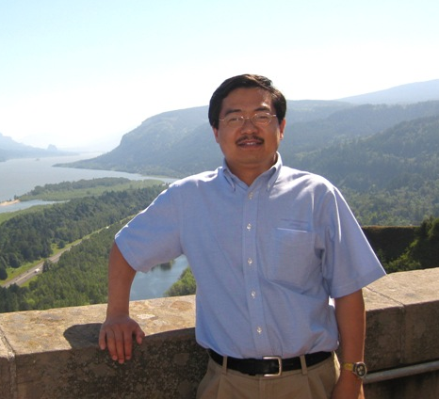 | Nominee Name:  Gary Hou  Position for Nominee:  President 2011  Region:

Experience (indicate professional, community, and university experience):

- Technical Director and Asian Foods Specialist, 1995-present
Wheat Marketing Center, Inc., Portland, OR 97209

Since joining the Wheat Marketing Center in 1995, Dr. Hou has served as the Program Manager for the Asian Products Collaborative project from 1996 to 2008 and the End Products Collaborative project from 2009 to present. Both projects were joint projects of U.S. Wheat Associates and Wheat Marketing Center.
Dr. Hou has conducted numerous research projects and published more than a dozen peer-reviewed articles and industrial papers. He has edited a monograph “Asian Noodles: Science, Technology, and Processing”, the only English book providing comprehensive coverage on Asian noodles. The book was published by Wiley & Sons, Inc. in September 2010.
Dr. Hou is the Course Director of “Asian Noodle Technology Short Course”, “Asian Noodle Technology and Ingredient Application Short Course”, “Advanced Asian Noodle Technology Short Course”, “Whole Wheat Flour Product Development Short Course”, “Flat Bread Short Course”, “Steamed Bread Technology Short Course”, “Bread and Hamburger Bun Technology Short Course”, “Artisan Bread Baking Course”, and “Bagel Baking Course”. New courses are being developed each year.
Dr. Hou has traveled to over 30 countries and consulted with numerous international companies on wheat flour application.

- University Experience
Adjunct Professor of Oregon State University, USA, 2009-present
Guest Professor of Anhui Agricultural University, China, 2007-present
Lecturer, Jiangnan University, 1991-1992

- Expert Consultant, U.S. Wheat Associates, 1996-present

- Professional membership
Professional member of AACC International, 1996-present
Professional member of Institute of Food Technologists, 1996-present

- Co-Chair, AACC International Asian Products Technical Committee, 2009-present

- President, NAJUA, 2010-2011

- AACC International Scholarship Committee, 2009-present
AACC International Soft Wheat Quality Technical Committee, 1996-present

Education (indicate institutions, degrees, year, and major fields):

Ph.D. in Food Science, Dept. of Food Science & Human Nutrition, Michigan State University, 1995.
M.S. in Food Science, Dept. Of Food Science & Engineering, Jiangnan University, 1990.
B.S. in Food Analysis, Dept. of Food Science & Engineering, Jiangnan University, 1988.

Statement (Vision and Ideas regarding the position nominated with NAJUA):
I am currently serving as the President of NAJUA since September 2010. During this period, I have worked very closely with the NAJUA Board of Directors and Executive Committee Team members and we have executed several important activities as well as new initiatives. If am elected for another term, I’ll continue to improve the NAJUA website to make it more informative and accessible to our members and other viewers. I’d like to complete the registration of NAJUA tax-exempt status and the NAJUA history write-up. I’ll develop strategies to expand our membership and get more members involved in our activities. Most important, I’ll make best efforts to serve our members better.

I have discussed the responsibilities of the position with a Nominating Committee member so that I am fully informed of its responsibilities.
Nominee_____Gary Hou_________April 13, 2011__
Signature Date
NOTE: Additional sheets may be attached.

